**SQL Academic General-Purpose Queries**

***1. List all the students in computer science department?***

This Query displays all the students under the computer science department in the university database. The query is written as below:

select student_id , student_name, department_name

from student_table

where department_name = 'Computer Science'

*Output:*

***2. List the student names and their IDs who secured an A grade in the university***

This Query displays the list of students i.e., their IDs and names who secured A grade. The query is written as below:

select distinct A.student_id, B.student_name,grade

from section_table A, Student_table B

where grade = 'A'

and A.student_id = B.student_id

*Output:*

It displays only those students who secured A grade

***3. List the instructor whose salary is between 100,000 and 150,000***

This query displays the details of those instructors in the university whose salary is between 100,00 and 150,000. The query is written as below:

select instructor_id, instructor_name, salary

from instructor_table

where salary between 100000 and 150000

*Output:*

***4. List the section and their respective location of the classes which are conducted on Saturday.***

This query displayed the locations of the sections i.e., room number and building of the classes that are being conducted on Saturday. The query is written as below:

select A.section_id, A.building,A.room_number,B.day

from section_table A, time_slot_table B

where A.time_slot_id = B.time_slot_id

and

day = 'Saturday'

Output:

***5. Create a view names as advisor where you print the instructors from Information and Decision Science department. From the view, get the instructors who are also advisors to students.***

This query deals with creation of view named Advisor, which lists the instructors from the Information and Decision Science Department. Using the view generated we make a query to display the list of instructors who are also advisors to students.

The query is written as below:

create view advisor as

select instructor_ID, instructor_name

from instructor_table

where department_name = 'Information and Decision Science';

select instructor_name from advisor A, student_table B

where A.instructor_id = B.instructor_id;

Output:

***6. Find all students who take at least one course in 2021***

This Query displays student ID and student name of all the students who take at least one course in year 2021 in the university database. The query is written as below:

select student_id, student_name

from student_table

where student_id in (select student_id

from section_table as S, course_table as C

where S.course_id = C.course_id

and S.year = 2021

Output:

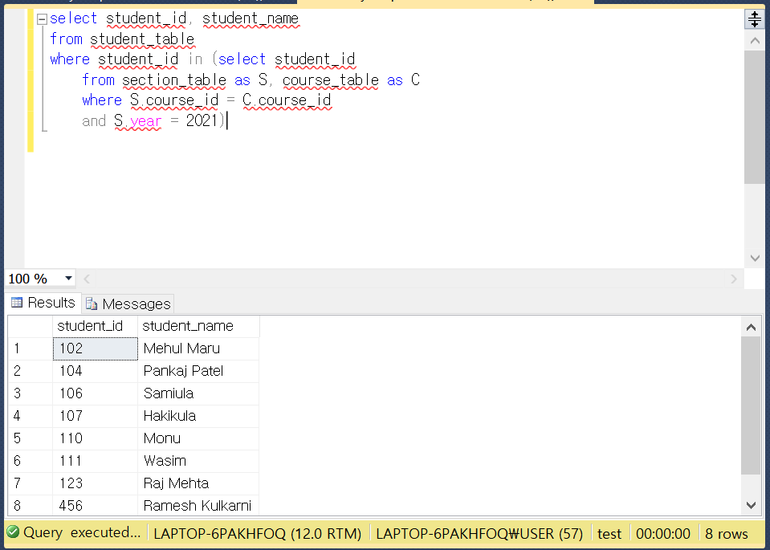

***7. Find all students whose advisor belong to IDS department***

This Query displays student ID and student name of all the students whose advisor belong to Information and Decision Science department in the university database. The query is written as below:

select S.student_id, S.student_name

from student_table as S, instructor_table as I

where S.instructor_id = I.instructor_id

and I.department_name = 'Information and Decision Science'

Output:

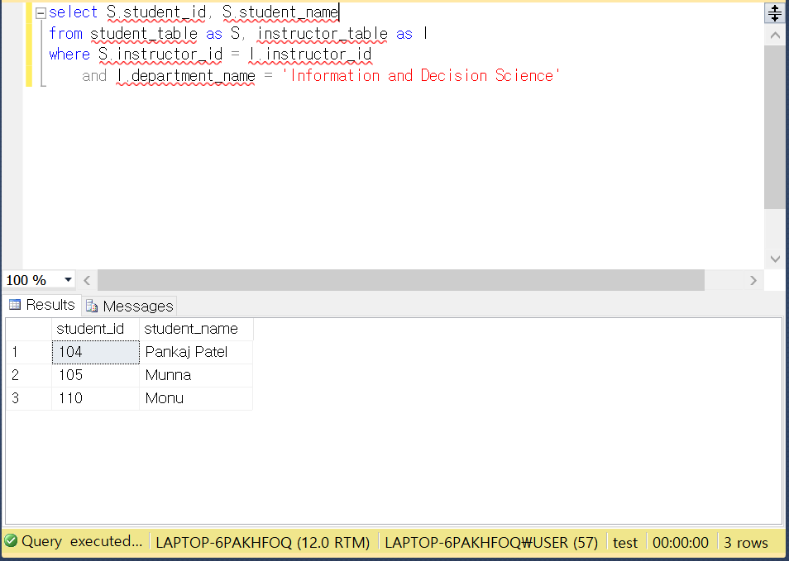

***8. Find all courses in year 2020***

This Query displays the course ID and title of all the courses which were opened in year 2020 in the university database. The query is written as below:

select C.course_id, C.course_title, S.year

from course_table as C,section_table as S

where C.course_id = S.course_id

and S.year = 2020

Output:

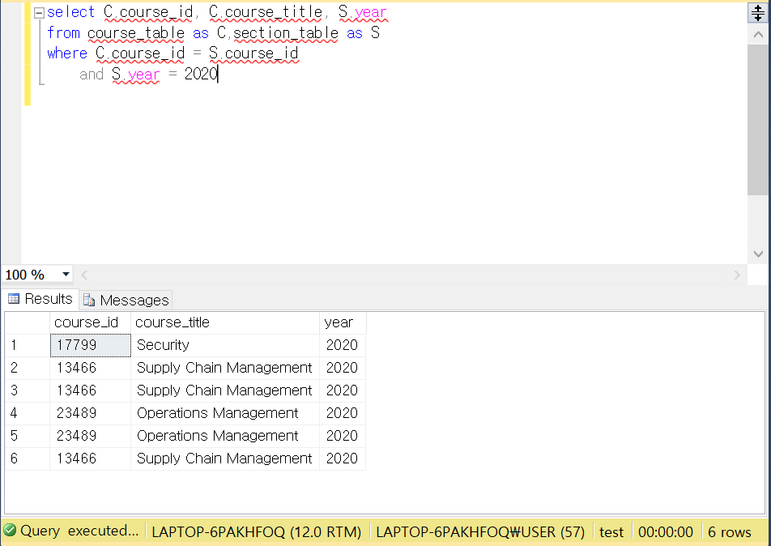

***9. Find title of courses of which credits are equal or less than 2***

This Query displays the course title and the credits of all courses of which credits are equal or less than 2 in the university database. The query is written as below:

select course_title, course_credit

from course_table

where course_credit <= 2;

Output:

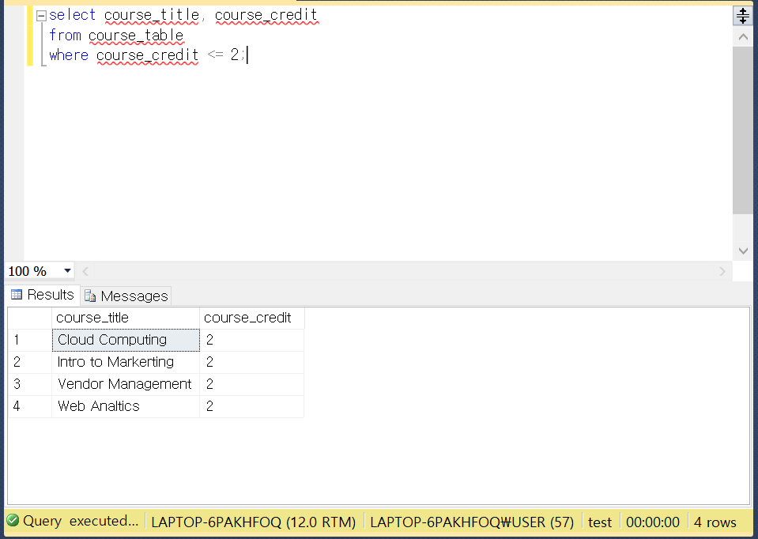

***10. Find all departments whose budget is more than 200000***

This Query displays the department names and each budget of all departments whose budget is more than 200000 in the university database. The query is written as below:

select department_name, budget

from department_table

where budget > 200000;

Output:

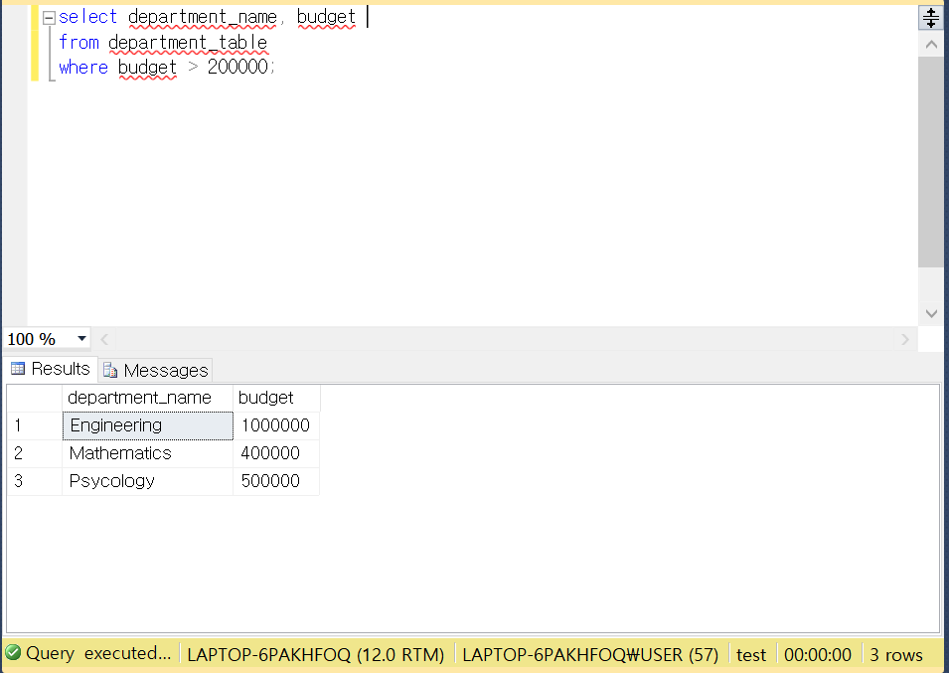

***11. Find out the department having maximum budgets.***

This query displays the Name and Budget of the department having maximum budget out of all the departments. The query is written as below:

select department_name, budget

from department_table

where budget = (select max(budget) from department_table);

Output:

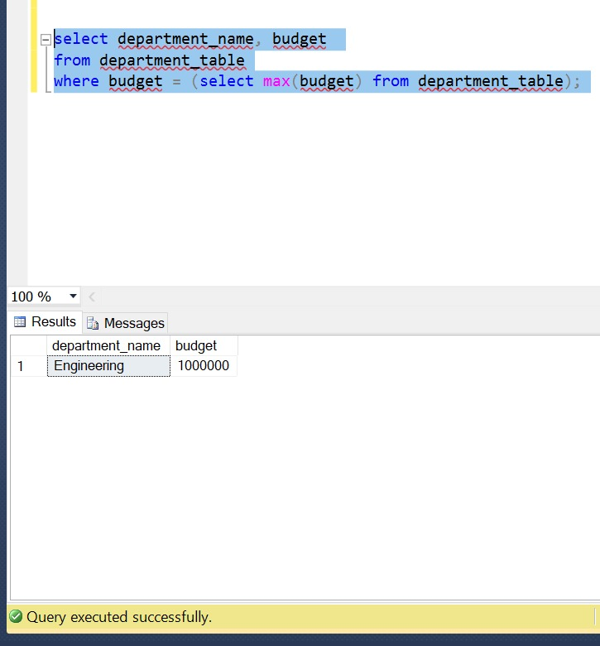

***12. List the classrooms whose capacity is greater than 100***

This query displays the details of classrooms having capacity more than 100. The query is written as below:

select * from Classroom_table

where capacity > 100:

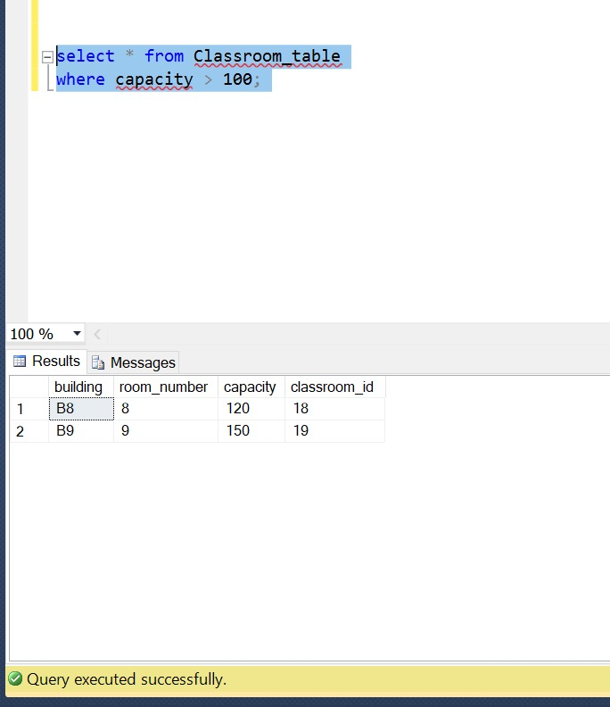

***13. Find out all the courses in which pre req is not required.***

This query displays all the course titles and ids in which no pre req is required. The query is written as below:

select course_id, course_title, prereq_id from course_table

where prereq_is = 0;

Output:

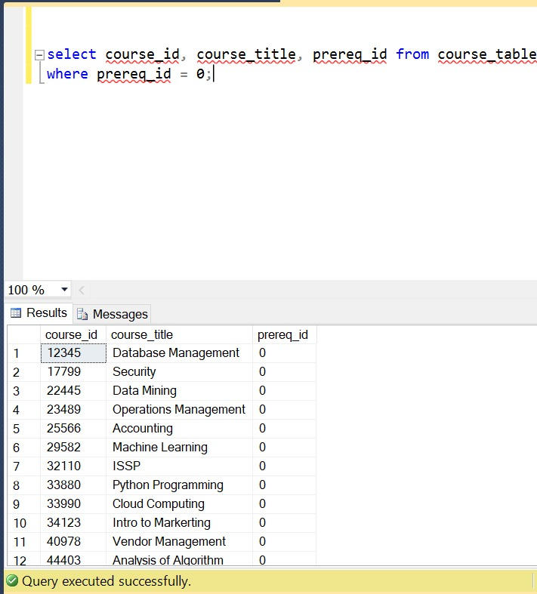

***14. Update the credits of a student***

This query updates the total credits of a particular student as per the attributes given by us in the update statement.

The query is written as below:

update student_table

SET total_credit=16

where student_id=116

Before Update :

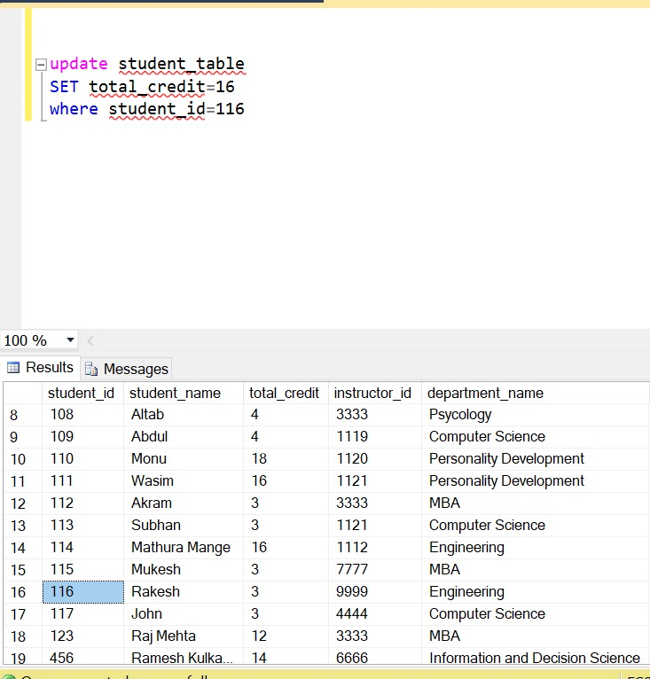

After Update :

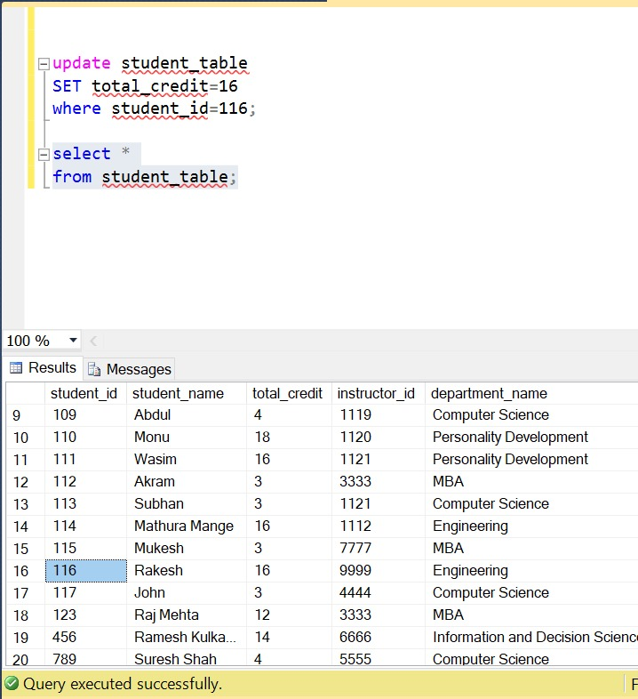

***15. Find out all the instructors whose salary is less than the average salary of the university.***

This query displays the name and salary of all the instructors having salary less than the average salary. The query is written as below:

select instructor_name, salary

from instructor_table

where salary < (select AVG(salary) from instructor_table)

Output:

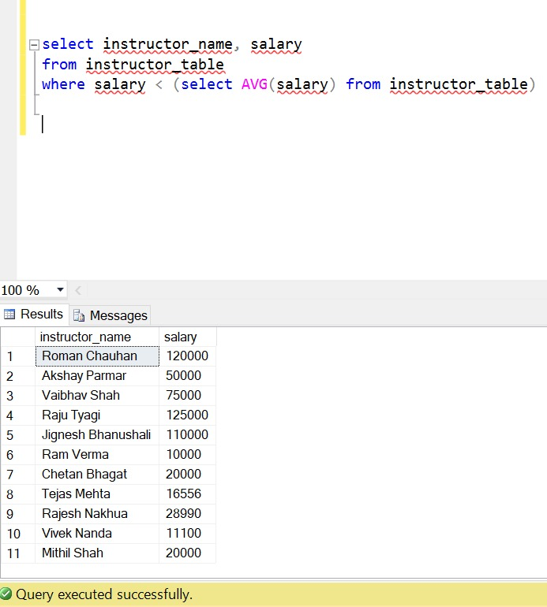

***16. Instructors who make more than 200,000 dollars a year***

This Query displays the name of all the instructors who make over 200000$ a year. The query is written as below:

select instructor_name

from instructor_table

where salary>200000

Output:

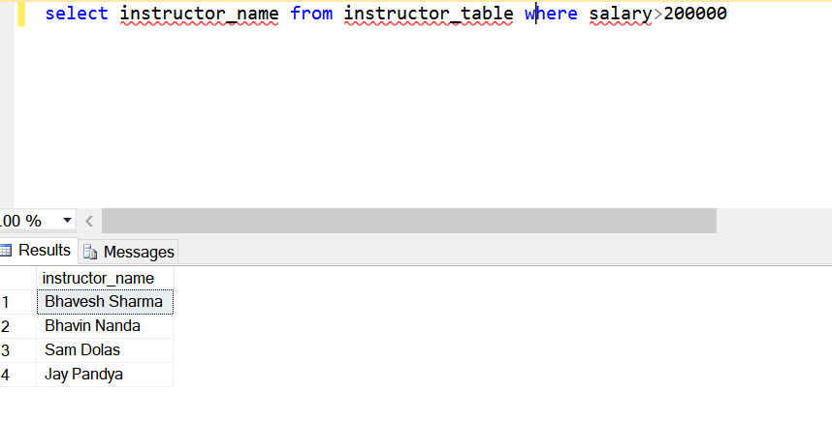

***17. Count of courses offered by the department***

This Query displays the total number of courses offered by each department. The Query is written as below:

select department_name,count(*), S.student_name

from course_table group department name

Output:

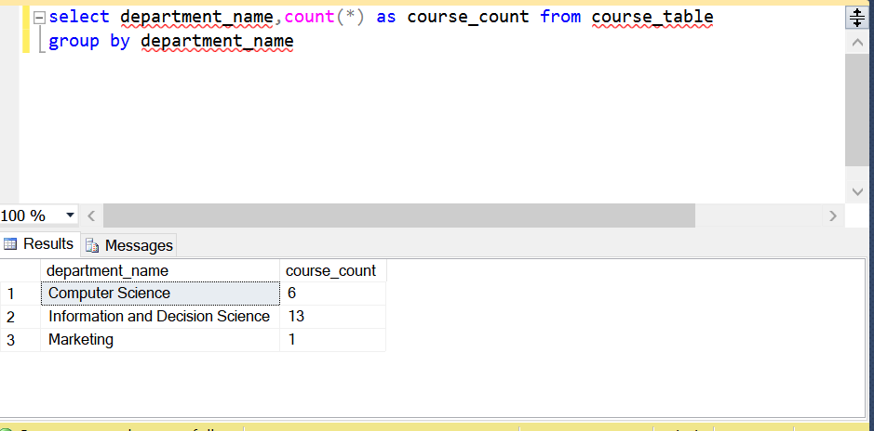

***18. Capacity of rooms larger than 100***

This Query displays the room number of rooms larger than 100. The query is written as below:

Select room_number

from classroom_table where capacity>100

Output:

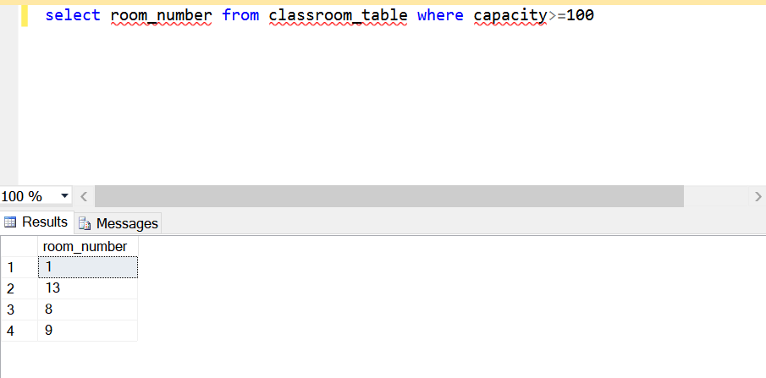

***19. Find total number of students from each dept***

This Query displays the total number of students of each department. The query is written as below:

select deoartment_name, count(*)

from student_table group by department_name

Output:

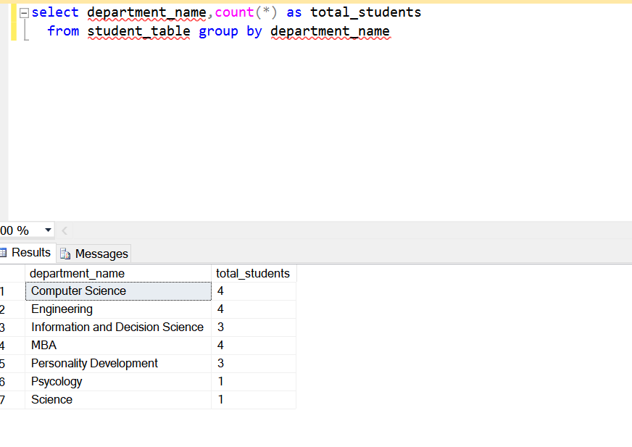

***20. Finding courses which require a prereq***

This Query displays the name of the courses which require a prereq. The query is written as below:

select course_title

from course_table

where prereq!=0

Output:

